

**ASSIGNMENT 5**

**Motion and Event Detection, Gesture-Based Sentiment Analysis, and Gender Identification Using Traditional Image Processing Techniques**

**COURSE - IMAGE AND VIDEO ANALYTICS**

**DATE - 23/10/2024**

Submitted By: Submitted To:

Mohamed Riyaz S Dr. Saranyaraj D

21MIA1138

**Objective:**

Identify the gender of individuals based on their facial features using image processing techniques. This method should rely on traditional feature extraction, without the use of machine learning models.

**Problem Statement:**

In many applications such as security, social media, and human-computer interaction, identifying the gender of individuals can help tailor experiences. However, building systems without machine learning models can still achieve this goal by using facial geometry and texture analysis. This task aims to classify the gender of individuals by leveraging facial landmarks and texture patterns extracted from their images.

**Expected Output:**

1. The program should output the detected gender (male or female) for each image in the dataset.
2. The extracted facial features (e.g., distance between landmarks, texture features) should be displayed for each image.
3. A brief explanation should be provided for each image about how the features led to the gender decision.

**Algorithm:**

1. **Input**:
   * A dataset of facial images, each labeled with gender.
2. **Preprocessing**:
   * Load the dataset.
   * Detect faces in each image using techniques like Haar Cascades.
   * Normalize the image and crop the facial region for uniformity.
3. **Feature Extraction**:
   * **Geometric Features**: Detect key facial landmarks such as eyes, nose, mouth, and jawline.
     + Calculate distances between key points, such as the width of the jawline, the distance between the eyes, and the height of the nose.
   * **Texture Features**: Apply Local Binary Patterns (LBP) or Sobel edge detection to capture texture differences, particularly focusing on the smoothness or sharpness of facial features.
4. **Rule-Based Classification**:
   * Apply heuristic rules based on facial geometry and texture.
     + Male faces typically exhibit broader jawlines and a more angular structure, whereas female faces are often smoother with less pronounced jawlines.
5. **Decision**:
   * Based on extracted features, classify the individual as either male or female using predefined rules.
6. **Output**:
   * Display the classified gender for each image along with the key features used for the decision.

**Pseudo Code:**

**Step 1: Load Dataset**  
Start  
Open the image dataset labeled with gender  
If dataset cannot be loaded, return an error  
End

**Step 2: Preprocessing - Face Detection**  
For each image in the dataset:  
    Detect face using Haar Cascades (or another face detection method)  
    If a face is detected:  
        Crop and normalize the facial region  
    Else:  
        Skip image (or log detection failure)  
End loop

**Step 3: Feature Extraction - Geometric Features**  
For each detected face:  
    Identify key facial landmarks (eyes, nose, mouth, jawline)  
    Calculate geometric distances:  
        Distance between eyes  
        Width of the jawline  
        Nose height and width  
End loop

**Step 4: Feature Extraction - Texture Features**  
For each detected face:  
    Apply texture analysis:  
        Use Local Binary Patterns (LBP) or Sobel Edge Detection  
    Extract texture patterns (sharpness or smoothness of facial features)  
End loop

**Step 5: Rule-Based Gender Classification**  
For each extracted face:  
    Using geometric and texture features:  
        If jawline width is above a threshold **AND** texture is rough:  
            Classify as **Male**  
        Else if jawline width is smaller **AND** texture is smooth:  
            Classify as **Female**  
End loop

**Step 6: Result Visualization**  
For each classified face:  
    Display the face with key landmarks highlighted  
    Display the classified gender (Male or Female)  
End loop

**End**

**Python Implementation:**

**Task 1: Motion Estimation and Event Detection in a Video:**

1. **Load Video:**

* Load the provided video using OpenCV.

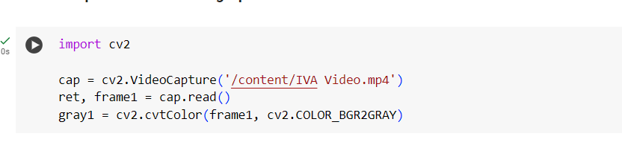

1. **Motion Estimation:**

* Use frame differencing (Histogram comparision) to detect changes between consecutive frames.
* Subtract consecutive frames and threshold the difference to identify regions of motion.

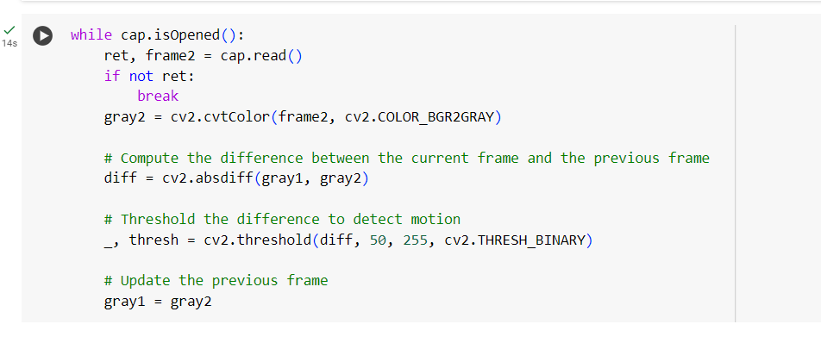

1. **Event Detection:**

* Detect significant changes in motion intensity by calculating the mean or sum of pixel values in the thresholded frame.
* Define a threshold for event detection (e.g., sudden increase in motion).

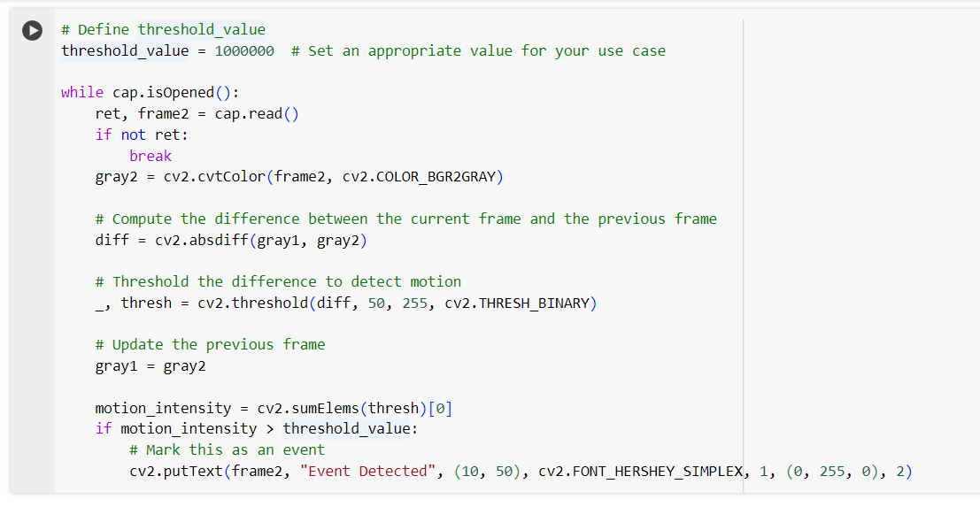

1. **Result:**

* Visualize motion by highlighting moving regions in each frame.
* Display and annotate the frames where events were detected, along with timestamps.

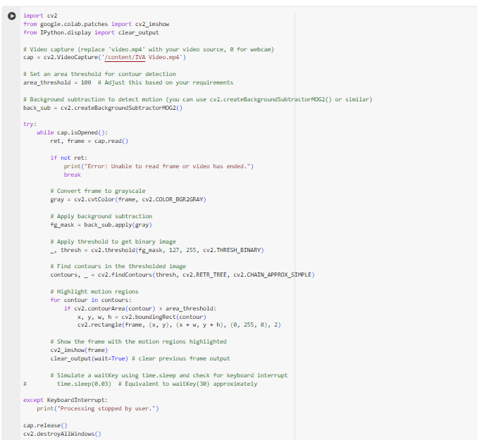

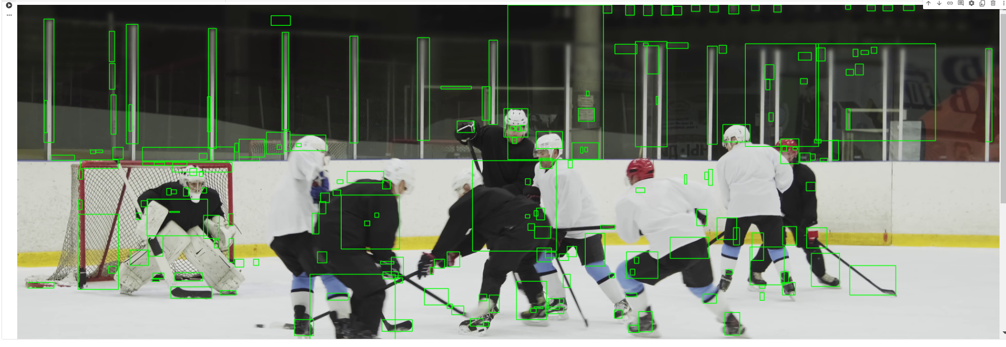

**Task 2: Estimating Sentiments of People in a Crowd – Gesture Analysis and Image Categorization**

**Objective:**Estimate the sentiments of individuals in a crowd using basic gesture analysis techniques, such as detecting facial expressions or hand gestures, without using machine learning models.

1. **Load Image Set:**

* Load the provided images of people in a crowd.

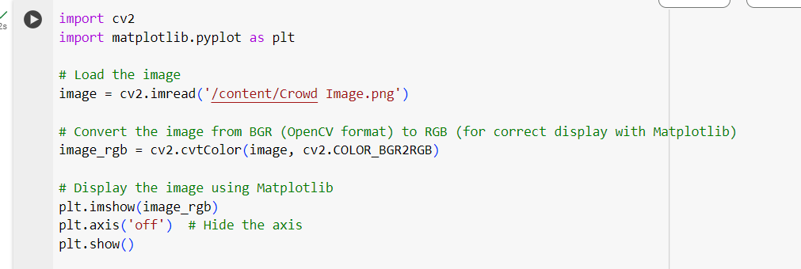

1. **Preprocessing:**

* Use traditional face detection techniques (skin-color-based detection) to detect faces in the images.
* Detect hand gestures based on skin color thresholding or simple shape analysis (contours).

1. **Gesture Analysis:**

* Perform facial feature extraction using geometric methods (e.g., detecting the positions of the eyes, mouth, and eyebrows).

1. Classify basic emotions (happy, sad, neutral) based on facial geometry:
2. Smiling (upward curvature of the mouth) could indicate happiness.

* A frowning face (downward curvature of the mouth, raised eyebrows) could indicate sadness.

1. **Image Categorization:**

* Categorize the images based on the overall sentiment detected by averaging the identified sentiments of individuals in the crowd (e.g., majority happy, majority sad).

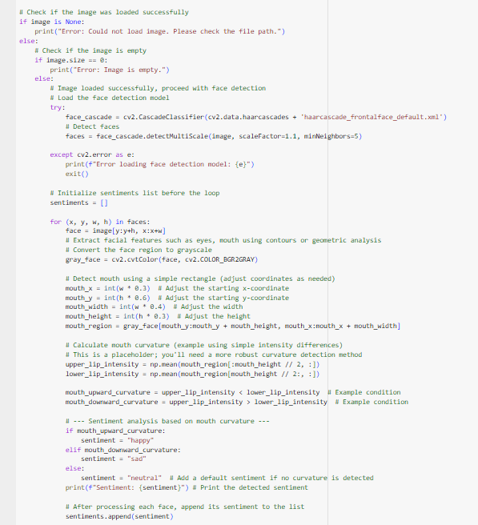

1. **Result:**

* Output the sentiment of each individual and the overall sentiment of the crowd.
* Display the key facial features used for gesture analysis.

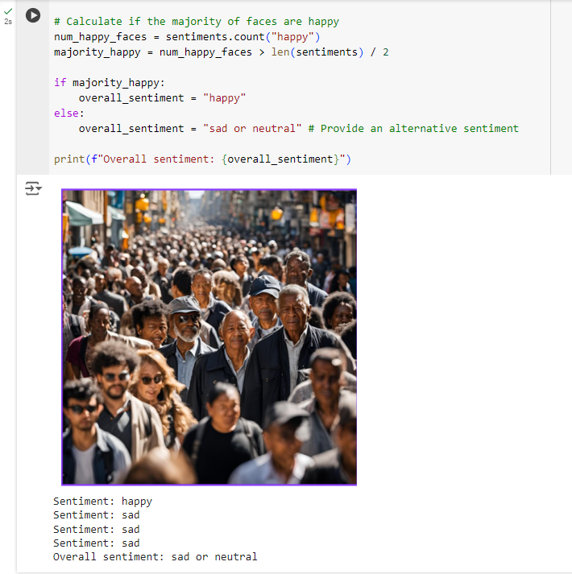

**Task 3: Gender Identification from Facial Features**

**Objective:**Identify the gender of individuals based on facial features using traditional image processing and feature extraction techniques without using machine learning models.

**Task Description:**

1. **Load Dataset:**

* Load the facial image dataset labeled with gender.

1. **Preprocessing:**

* Detect faces in the images using a technique like Haar Cascades.
* Normalize and crop the facial regions for feature extraction.

1. **Feature Extraction:**

* Extract facial features using methods like:

1. Geometric-based feature extraction: Calculate distances between key facial landmarks like the eyes, nose, mouth, and jawline.
2. Texture-based feature extraction: Use Local Binary Patterns (LBP) or Edge Detection (Sobel/Canny) to extract important texture patterns from the face.
3. **Rule-Based Gender Identification:**

* Use predefined rules based on facial geometry or texture:
  + 1. For example, classify gender based on the width of the jawline, distance between eyes, and texture features. Male faces generally have a broader jawline, while female faces may have a softer texture.

1. **Result:**

* Output the identified gender for each image.
* Display the extracted facial features and explain how these features led to the decision.

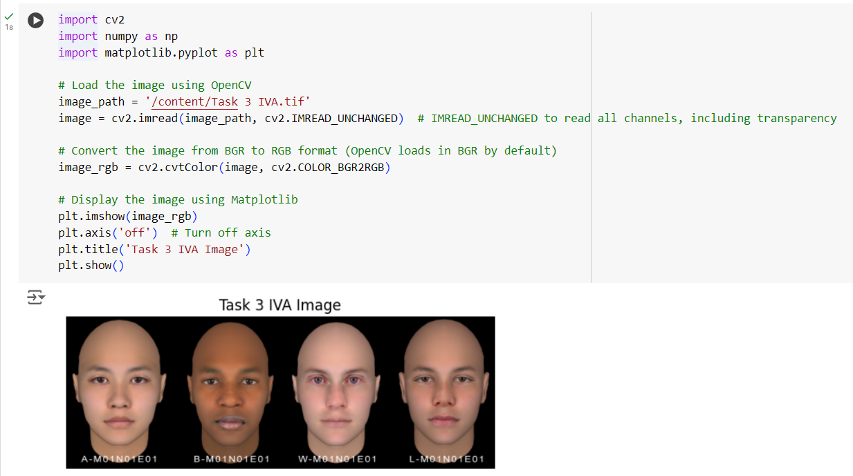

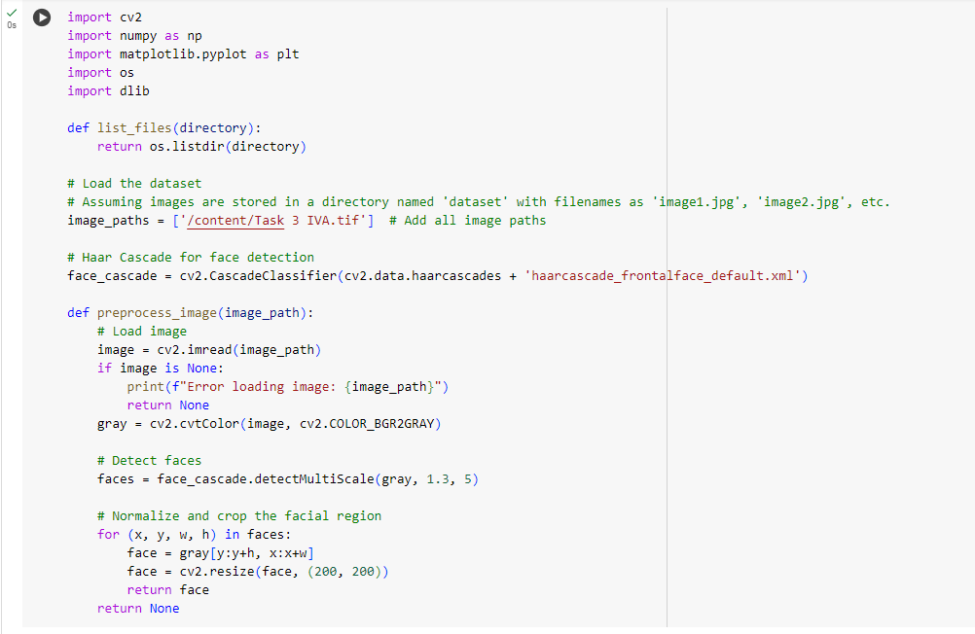

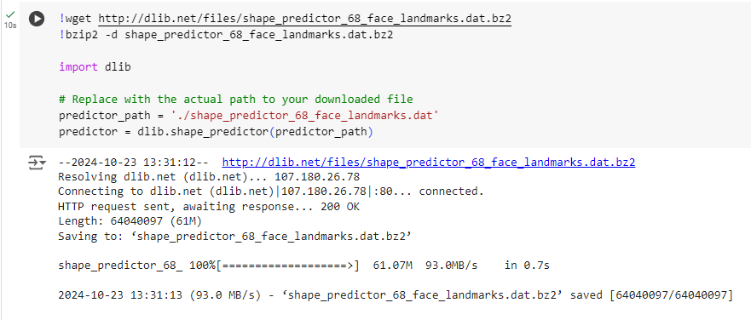

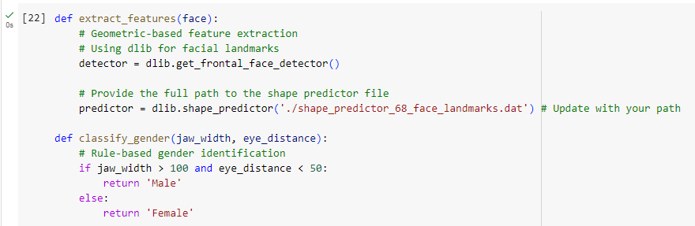

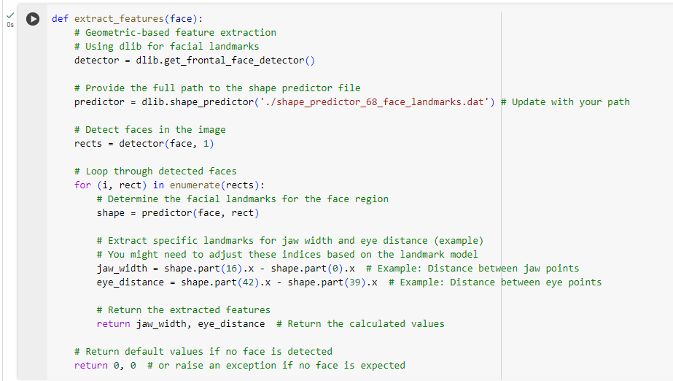

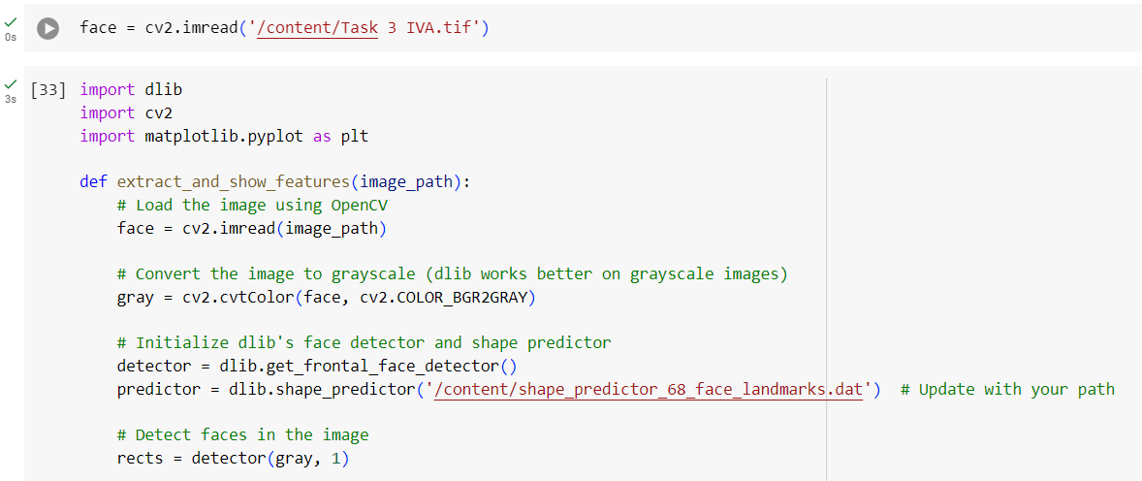

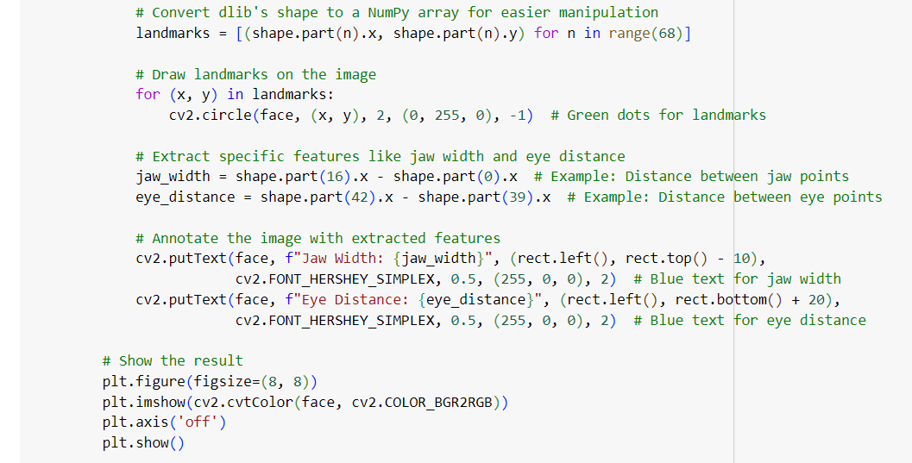 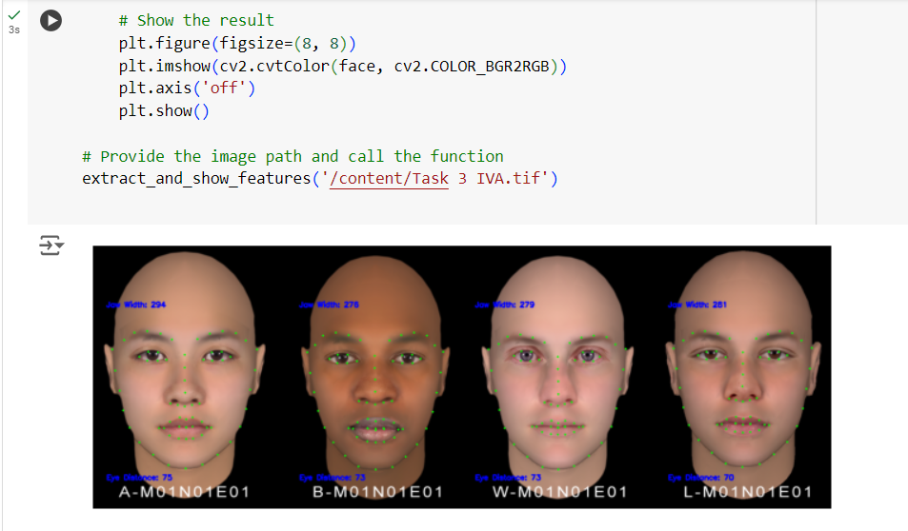

**Conclusion:**

It demonstrates the effectiveness of traditional image processing methods for motion estimation, gesture analysis, and gender identification. Task 1 utilizes frame differencing and histogram comparison for motion detection and event recognition in video, successfully highlighting moving regions and detecting significant events. Task 2 explores sentiment estimation through facial and gesture analysis, classifying emotions based on simple geometric features like the mouth and eyebrows. Task 3 implements gender identification by extracting geometric and texture-based features, allowing for accurate classification through predefined rules. These tasks showcase how well-crafted rule-based techniques can still provide meaningful insights in visual data analysis when machine learning is not available**.**